

**Bubble Destroyer**

**Presented By**

**Kanokprapha Kawilo 6604062661016**

**Presented to**

**Asst.Prof.Sathit Prasomphan**

**Object-Oriented Programming 040613204 Semister 1 / 2024**

**Department of Computer and Information Science, Faculty of Applied Science**

**KING MONGKUT'S UNIVERSITY OF TECHNOLOGY NORTH BANGKOK**

**Chapter 1**

**Introduction**

* 1. **Background and Significance**

This project was created to assess learning outcomes in the course "Object-Oriented Programming" (OOP) by applying the content from lessons to build a game. The game is designed for single-player mode to enhance concentration, develop quick thinking, and provide stress relief.

* 1. **Objectives**  
      1.2.1 To apply the knowledge gained from the course in a practical project  
      1.2.2 To gain hands-on experience in Java programming

**1.3 Scope of the Project**  
 1.3.1 Java is used as the primary programming language  
 1.3.2 The project is designed and developed following Object-Oriented Programming (OOP) principles

**1.4 Work Plan Schedule**

|  |  |  |  |  |  |
| --- | --- | --- | --- | --- | --- |
| **Order** | **List** | **9 – 13 OCT** | **14 OCT –3 NOV** | **4 -6 NOV** | **%** |
| **1** | **Design game** |  |  |  | **10 %** |
| **2** | **Study related information** |  |  |  | **20 %** |
| **3** | **Write code** |  |  |  | **60 %** |
| **4** | **Add code details** |  |  |  | **65 %** |
| **5** | **Edit code** |  |  |  | **80 %** |
| **6** | **Test code** |  |  |  | **85 %** |
| **7** | **compile a document** |  |  |  | **90 %** |
| **8** | **Check for errors** |  |  |  | **100 %** |

**Chapter 2**

**Game**

**2.1 Details**

A dangerous situation has arisen in space as many rocks and meteor fragments are floating towards us. Little Bubble has been given the important task of protecting space with the ability to destroy all dangerous objects. To prevent these threats from causing harm, Little Bubble serves as the guardian, ensuring the safety of the space we inhabit.

**2.2 Game Details**

A dangerous situation has arisen in space as many rocks and meteor fragments are floating towards us. Little Bubble has been given the important task of protecting space with the ability to destroy all dangerous objects. To prevent these threats from causing harm, Little Bubble serves as the guardian, ensuring the safety of the space we inhabit.

**2.3 How to play**

Press control movement.

- Press w to move up.

- Press s to move down.

- Press a to move left.

- Press d to move right.

- Press f to rotate left.

- Press r to rotate right.

- Press enter to shoot.

2.4 Storyboard

**Character**

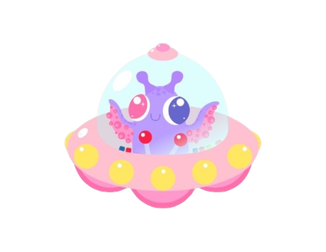 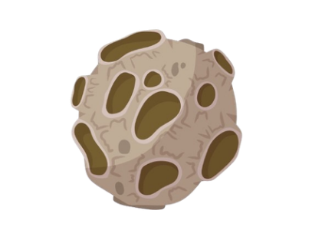 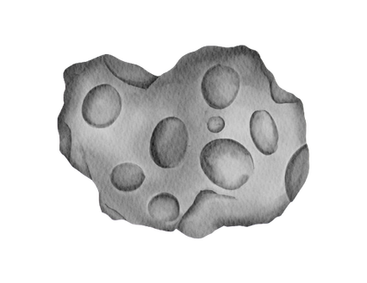 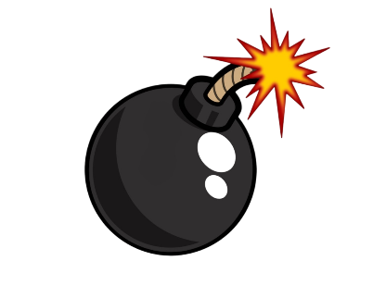 

Blood

health 25%

Bom

Total score - 5.

Rock

score + 2.

Destroyter

score + 1.

Bubble

player

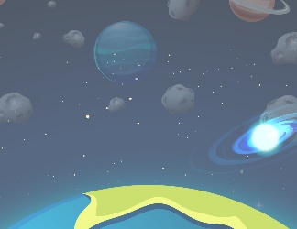 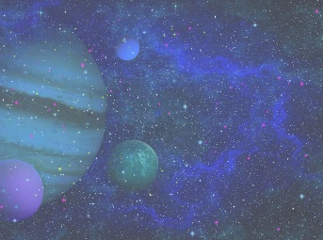  

Level 3

Level 2

Level 1

Page Menu

**Scene**

Press Start to begin the game. Press Exit to exit the game. 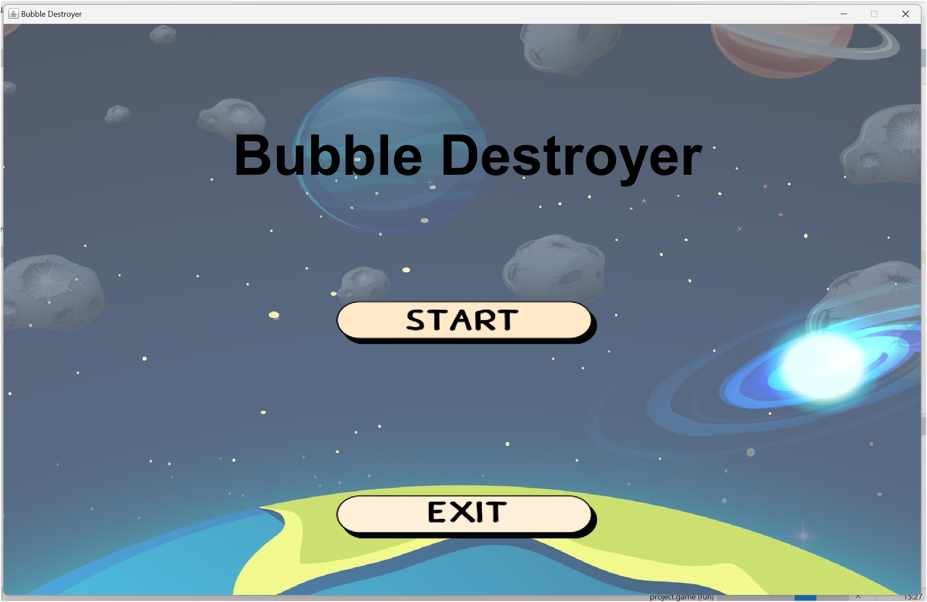

When you press Start, the game will begin at Level 1. You need to score 20 points to advance to the next level.

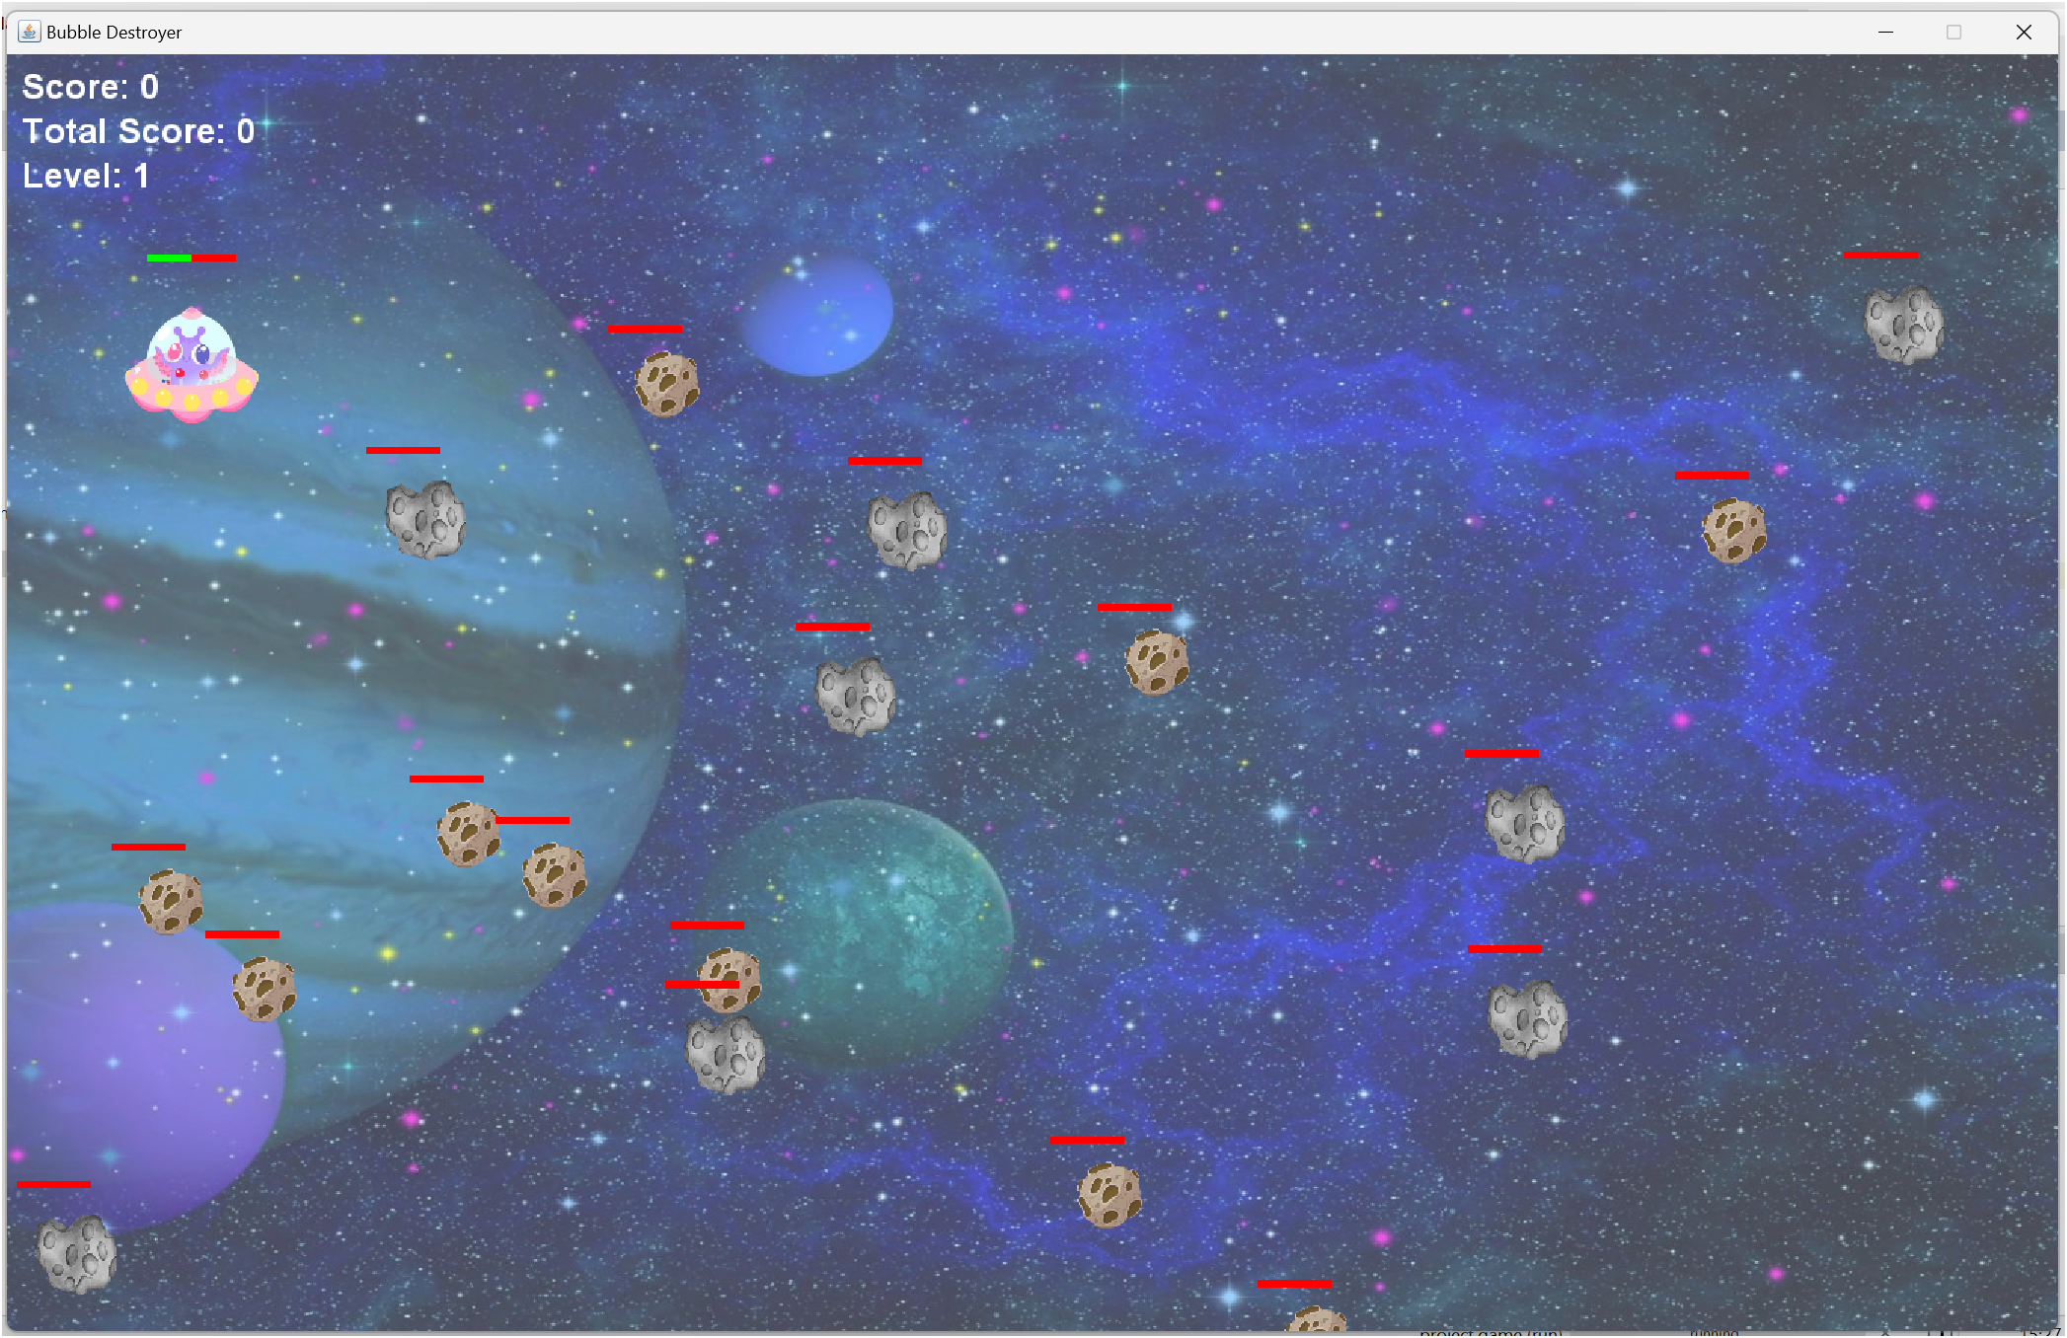

When you reach 20 points, the game will advance to Level 2. The score from Level 1 will be added to the total score, and additional bombs and health will be provided. In Level 2, you need to score 40 points to move on to the next level.

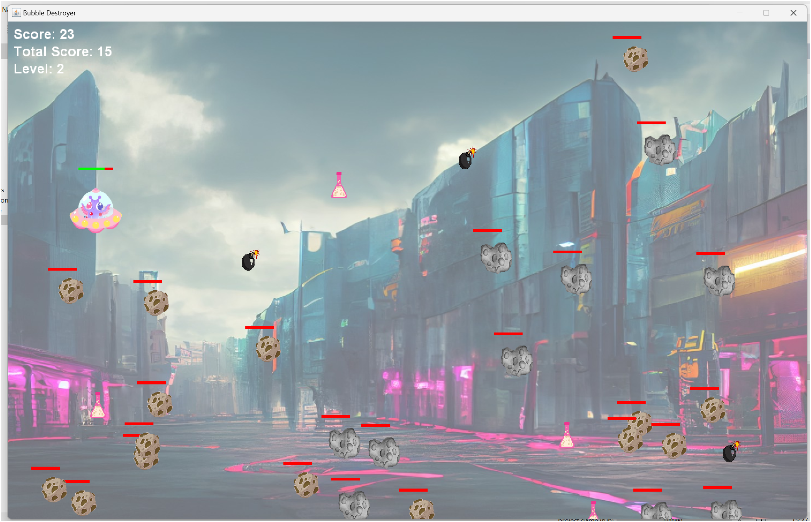

When you reach 40 points, the game will advance to Level 3. The scores from Levels 1 and 2 will be added to the total score, with additional bombs and health provided. In this level, you must eliminate all Destroyers and Rocks to win.

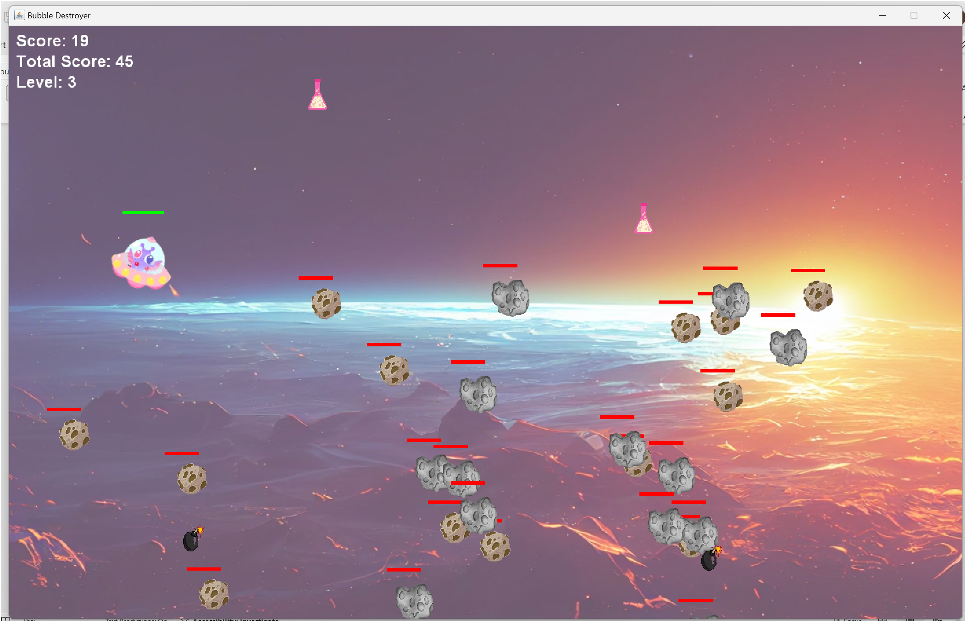

Page Game Over!!! Background will Level.

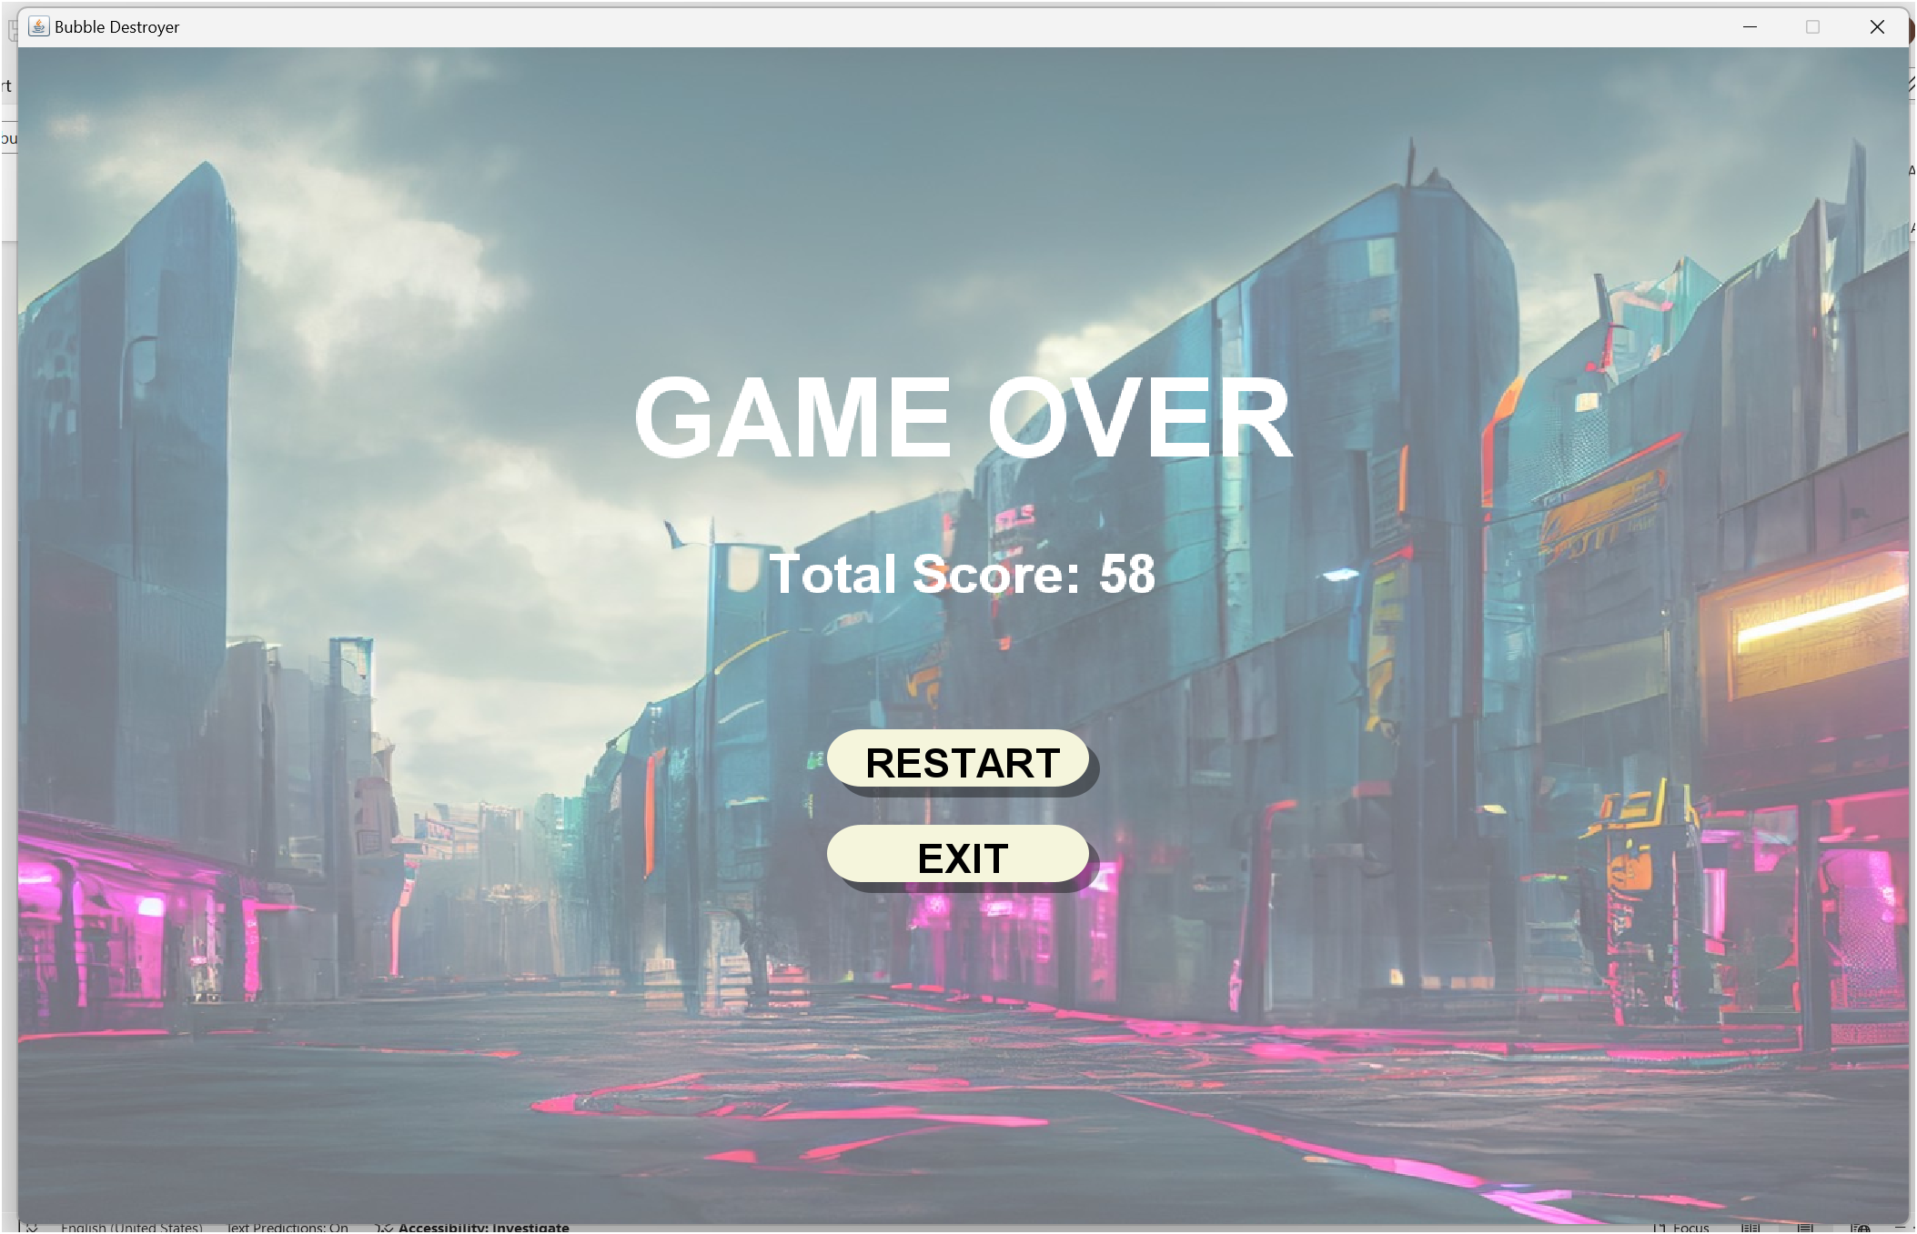

Page YOU WIN!.

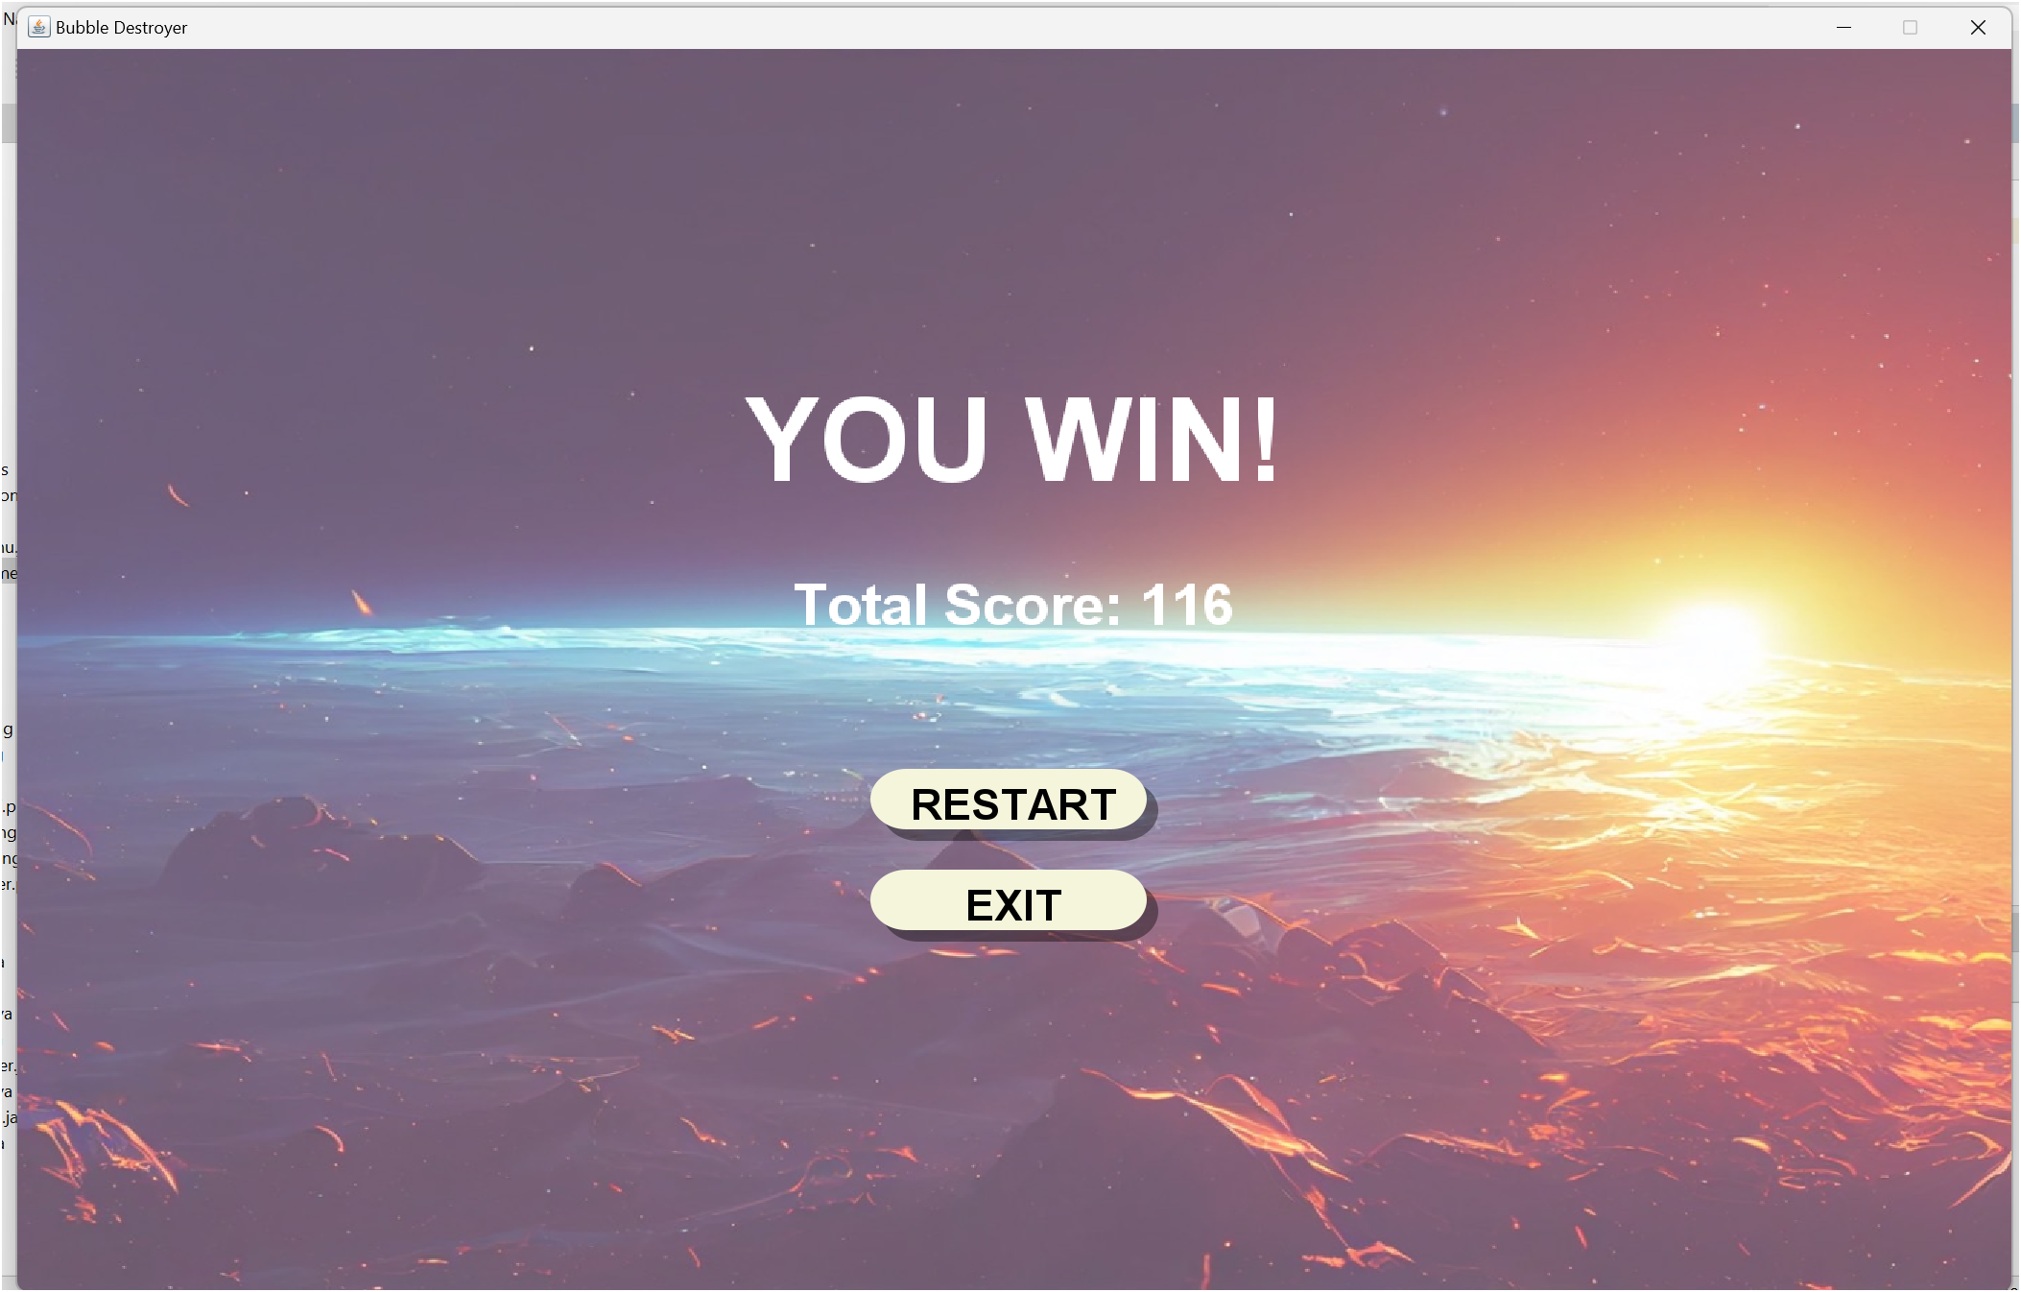

2.5 Class Diagram

**There are a total of 10 class diagrams.**

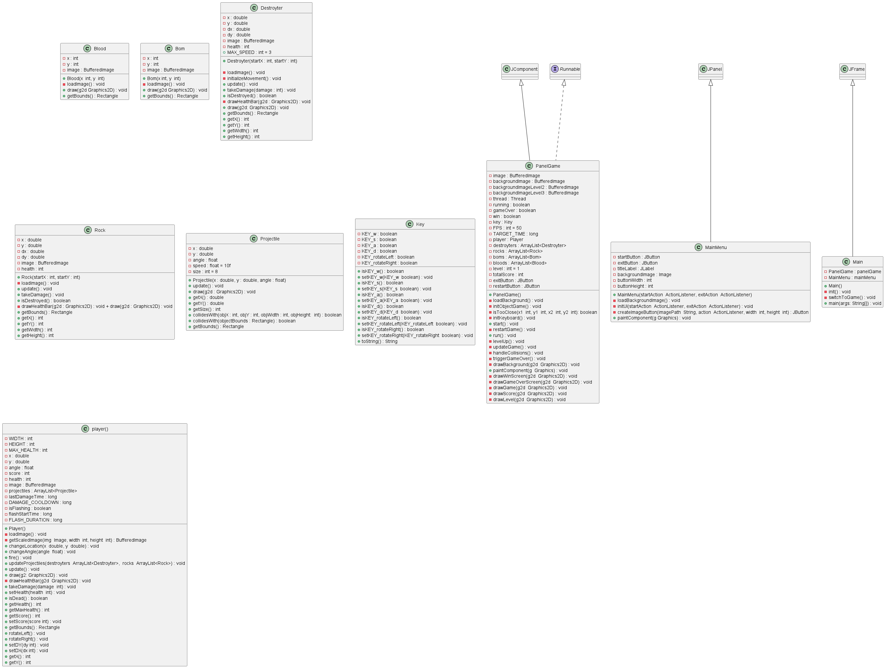

1.Class Main

1.Class Main

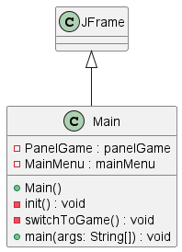

2.Class PanelGame

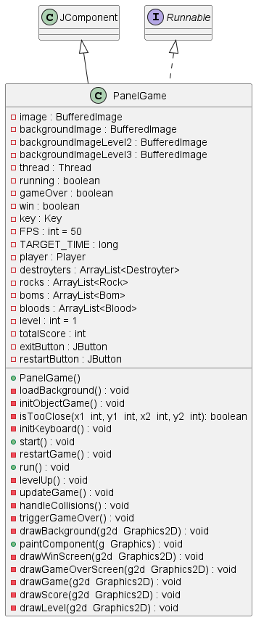

3.Class Player

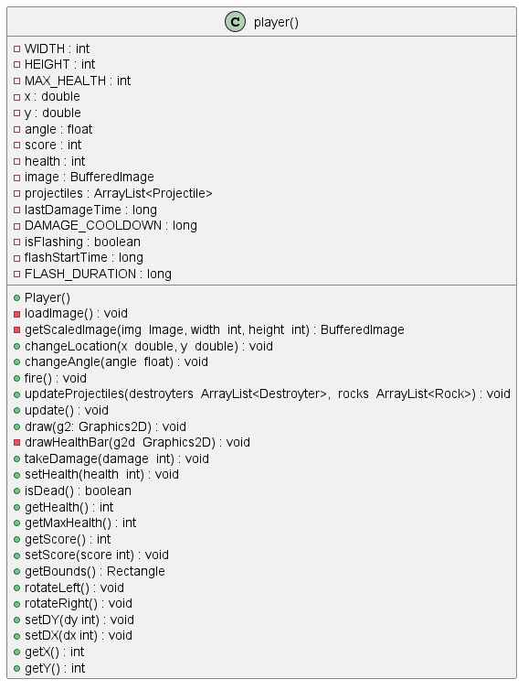

4.Class Destroyter

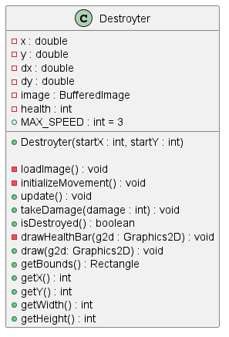

5.Class Rock

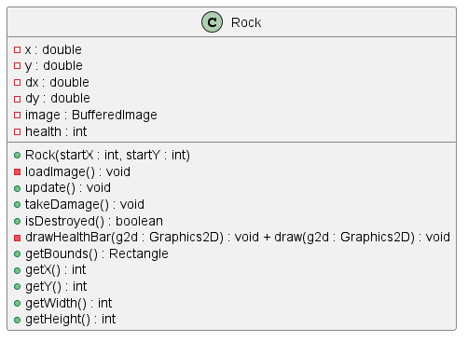

6.Class Bom

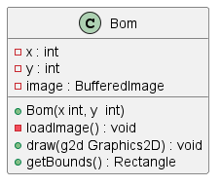

7.Class Blood

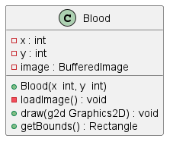

8.Class Projectile

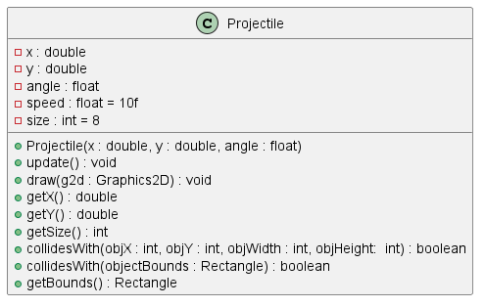

9.Class Key

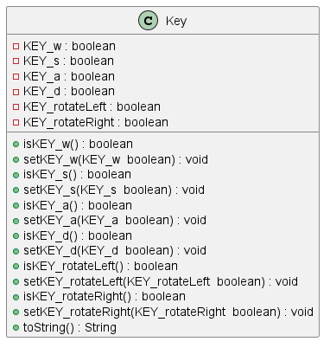

10.Class MainMenu

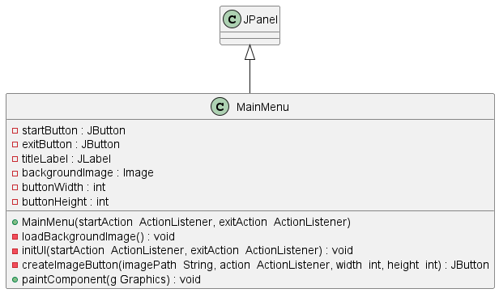

**Code**

1.Class Main

|  |  |
| --- | --- |
|  | **Constructor** must implement the init() method in addition to the methods used to initialize the game window by the init() method. |
| **Encapsulation** hiding the inner workings of variables and methods related to panelGame and mainMenu that are set to private |
|  | **Composition** PanelGame and MainMenu as components for creating the game window.  In the switchToGame() method there is a switch from mainMenu to panelGame. |

|  |  |
| --- | --- |
|  | **Event Handling** is used for button clicks and window openings:  StartGameAction Used to handle the "Start Game" button click event to switch to the game.  addWindowListener Used to handle the windowOpened event to start the game. (panelGame.start()) when the window opens. |
|  | **Polymorphism** is used in the StartGameAction section which implements the ActionListener interface. and use it through the method actionPerformed |

2.Class PanelGame

|  |  |
| --- | --- |
|  | **Constructor** is used to initialize the game's settings, such as screen size, background image loading. and UI settings initObjectGame() method is called to create game objects such as Player, Destroyter, Rock, Bom, and Blood, and initKeyboard() is to set the keyboard. |
|  | **Composition**  PanelGame combines the Player, Destroyter, Rock, Bom, and Blood objects to create various game elements in initObjectGame(). |
| **Encapsulation** in PanelGame prevents access to private variables such as players, destroyters, rocks, boms, bloods, which are only used within the class. These are accessed and manipulated only through methods within the class  These are accessed and manipulated only through methods within the class (e.g., updateGame(), handleCollisions()).  **Polymorphism** occurs when updating and drawing in-game objects, such as Destroyter, Rock, Bom, and Blood, which are stored in their own separate ArrayList, and each object has a different behavior in the draw and update methods based on its characteristics. each class |
|  | **Event Handling**  This is done via the keyboard using the KeyAdapter, which captures key presses and releases to control player movement and character rotation. |
|  | **Thread** for continuous game status updates. Using the run() method |

3.Class Player

|  |  |
| --- | --- |
|  | **Constructor** is used for basic initialization, such as loading the player image and creating an ArrayList for projectiles. |
|  | **Encapsulation** Prevent direct access to important variables. By setting variables like health, score, and projectiles to private, and creating getters and setters to manage external access to these values. |
|  | **Polymorphism** occurs when manipulating projectiles fired by players in a method. updateProjectiles() which calls the update() method for each projectile in ArrayList<Projectile> projectiles |

|  |  |
| --- | --- |
|  | **Constructor** of the Destroyter class is public Destroyter |
|  | **Encapsulation** By setting important variables such as x, y, dx, dy, and health as private to prevent direct access from outside the class. These variables are accessed through public methods. |
|  | **Composition** in this class is represented by a combination. BufferedImage for the Destroyter's image and use Random for the default enemy movement setting dx by BufferedImage It is loaded via the loadImage() method. |

4.Class Destroyter

5.Class Rock

|  |  |
| --- | --- |
|  | **Constructor** public Rock(int startX, int startY) is used to set the starting position of the Rock object and call the loadImage() method to load the rock image: |
|  | **Encapsulation** By setting the x, y, dx, dy, and health variables to private, this prevents direct access from outside the class. and allows access only through the public method. |
|  | **Composition** is used in Rock by combining a BufferedImage. for pictures of rocks It is loaded by the loadImage() method within the class. |

|  |  |
| --- | --- |
|  | **Constructor** is public Bom(int x, int y) used to set the initial position (x, y) of the explosive (Bom) and call the loadImage() method to load the image to be displayed. |
|  | **Encapsulation** By setting important variables such as x, y, and image as private to prevent direct access from outside the class. |
|  | **Composition** is used in Bom class with BufferedImage. is a component which is used to store images of Bom by BufferedImage It is loaded via the loadImage() method. |

6.Class Bom

7.Class Blood

|  |  |
| --- | --- |
|  | **Constructor** is public Blood(int x, int y) used to set the initial position (x, y) of the Blood object and call the loadImage() method to load the image to be displayed. |
|  | **Encapsulation** By setting important variables such as x, y and image as private to prevent direct outside access. |
|  | **Composition** is used in the Blood class using a BufferedImage. For storing images of Blood which are loaded via the loadImage() method. |

8.Class Projectile

|  |  |
| --- | --- |
|  | **Constructor** of the Projectile class is public Projectile(double x, double y, float angle) and is used to set the initial position (x, y) and angle (angle) of the projectile. |
|  | **Encapsulation** By making the variables x, y, angle, speed, and size private (or final for constants), this prevents direct outside access and modification. |
|  | **Composition** via creating a Rectangle representing the bounds of the bullet in the getBounds() and collidesWith() methods. |
|  | **Polymorphism** is implemented in the form of overloading the collidesWith() method. The parameters are coordinates (objX, objY) and dimensions (objWidth, objHeight).  Rectangle to define the boundaries of objects for collision detection. |

9.Class Key

|  |  |
| --- | --- |
|  | **Encapsulation** is used explicitly in this class. By setting the variables KEY_w, KEY_s, KEY_a, KEY_d, KEY_rotateLeft, and KEY_rotateRight. and |
|  | Access to these variables is done through public getter and setter. |
|  | **Polymorphis** toString() method is overridden from the Java Object class to display the state of all variables in text. |

10.Class MainMenu

|  |  |
| --- | --- |
|  | **Constructor** of the MainMenu class is public MainMenu(ActionListener startAction, ActionListener exitAction) used to create the game's main menu. By calling the method loadBackgroundImage() to load the background image and initUI(startAction, exitAction) |
|  | **Encapsulation** By setting important variables such as startButton, exitButton, titleLabel, and backgroundImage to private to prevent direct access from outside the class. |
|  | **Composition** in the MainMenu class uses a combination of objects. It is the main component of UI makes it possible to design the appearance of menus and customize the behavior of buttons. |
|  | **Inheritance** extends from Java Swing's JPanel, making it possible to use all of its functionality.  **Polymorphism** This method has been rewritten to draw a custom background instead of using JPanel's native drawing. |
|  | **Event Handling** ActionListener which is received as a parameter in the constructor and used to define the behavior of the startButton and exitButton buttons. |

**Chapter 3**

**Summary**

**Problems encountered during development**

1 Destroyter Rock has some parts where it moves in place.

2 Destroyter Rock through the edge.

**Unique program highlights**

1 Items have been added, namely Bom and Blood.

2 Total points are accumulated and counting new scores when passing the checkpoint

**Suggestions for teachers who want to explain**